|  |  |
| --- | --- |
| Team ID | PNT2022TMID26821 |
| Project Name | IOT Based Safety Gadget for Child Safety Monitoring and Notifications. |
| Maximum marks | 2 marks |

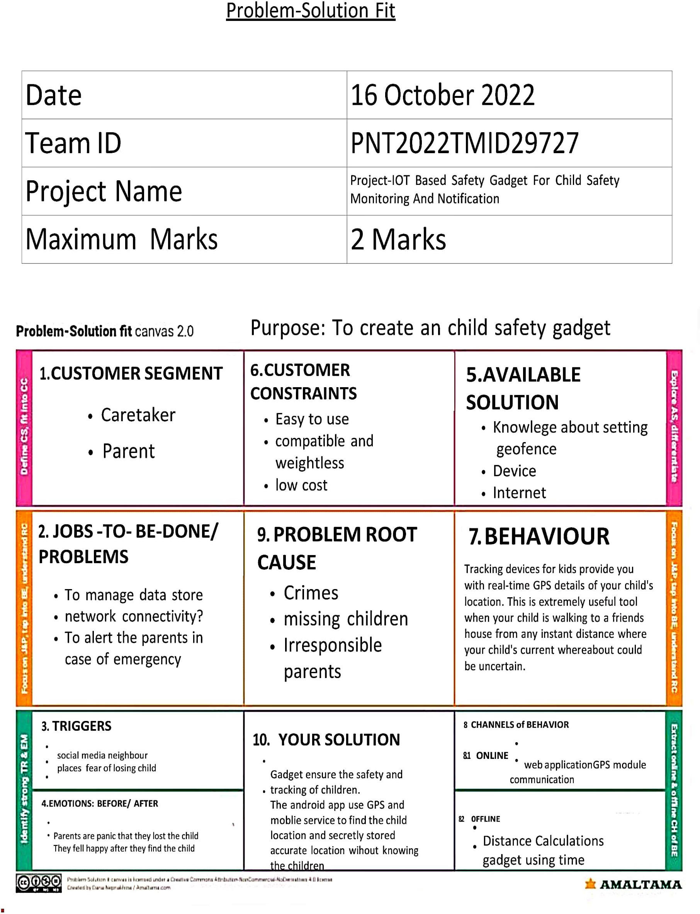Problem-Solution fit